***Preamble.***

In my humble opinion, Harold Vanderbilt started with what is now known as MiniBridge. While on a cruise with too much time on his hands, he decided that a complex, convoluted ***Bidding System*** would be more fun! Nonetheless, even without this complexity, MiniBridge still incorporates the concept of ***Bidding*** to win the ***Contract*** – that is, the largest number of Tricks that the final bidder ***Declares*** he will make, and in what suit. Thus the title **Contract Bridge** remains.

However, these Systems – again, in my opinion - can be a significant impediment to encouraging people to start out in Bridge. So, MiniBridge reverts to simply using High Card Points in determining who should have the Contract.

***The Game Itself.***

And so, in MiniBridge as in “Full” Bridge, players play in pairs, and sit at a Table opposite each other, against another pair. These ‘positions’ are called North, South, East and West. All 52 cards are dealt, and the Dealer counts and declares his High Card Points:

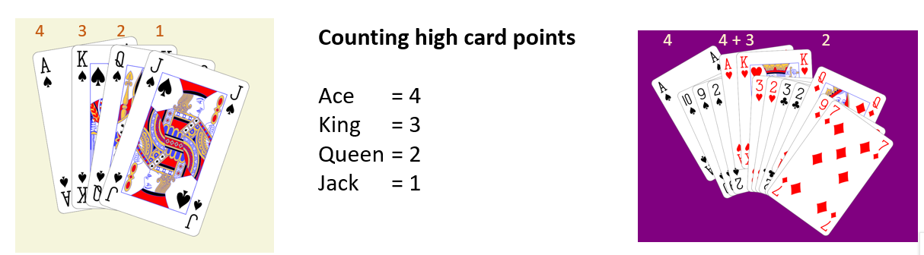

The other 3 pairs do likewise, and the pair with the biggest total are the Declarers. The player of the Declarers with the fewest points now places his cards face-up on the table – this is called the ***Dummy*** - and his partner now states how many tricks he will win, and in what suit (aka *denomination*). The denomination can be an actual suit – Clubs, Diamonds, Hearts or Spades – or No Trump. Note that in No trumps the highest card played **always** wins the Trick, whereas in a Suit contract, there is the option of ***Ruffing***. This is where a player has none of the Suit led, and so can play a Trump – thus winning the Trick.

Play now begins. The person on the Declarer’s left chooses the card from his 13 as the opening lead, and Declarer’s partner places his cards face-up on the Table for all to see – this is called the ***Dummy***. Declarer plays from both hands, as Dummy is now inactive. When all 13 cards are played, the number of Tricks made by Declarer determines the success or failure of the Contract. This result, in a Competition, is either recorded electronically, or entered into a Scoresheet which is hidden until the hand is played.

In a competition, the Pairs move around to all of the Tables and play against the other Pairs, with different Sets of Boards The number of Boards in a set will vary, and typically is dependent upon the number of Pairs playing. This competition is called ***Duplicate Contract Bridge***, and is the format used in most Bridge clubs.