***For-those-with-No-Idea.***

Here, we have a quick look at a set of procedures aimed at easing the Novices into trick-taking card games in general, and Bridge in Particular.

1. Sit 4 players at the table with the Pairs sitting opposite each other. To help picture this, we use the compass points to name them – North opposite South, and East opposite West. From an overhead perspective, these will appear

North

West East

South

1. Split the deck of cards into Suits, and remove the twos/deuces. South takes the Clubs, shuffles the micro-deck, and deals singly to all four players
2. West leads a card, by placing it face up on the table. North plays one of his cards, East next, then South. The best Club of the four has won the trick, and each player turns over his card, pointing towards the winning Pair. The winner of the trick now leads. This continues until all 3 cards are played. Have a brief chat about possible different plays.
3. Add the Diamonds to the micro-deck, and West deals. North leads off, and the play of the 6 cards proceeds as before.
4. Add the Hearts into the deck, North deals, and play proceeds as in (4)
5. Now we come to the ‘nitty-gritty’! Replace Spades in the deck ***along with the deuces***, and shuffle the deck well. East deals 13 cards to each player.
6. Now we are at the bones of Bridge. West leads, and North then places his cards, in order, face Up in front of him. This is called the Dummy, and the fact that all 3 players can see it’s contents will determine the course of the play. Furthermore, this is the facet of Bridge that makes it so special – you ***draw conclusions and make decisions based on collected facts in each hand played!***
7. At this point, a useful discussion can be held on the play, and also might it have been easier for South to make more tricks with a Trump Suit?

***MiniBridge Game.***

In MiniBridge, the players set up as before

North

West East

South

All 52 cards are dealt, starting with, say, South as dealer

1. South counts his High Card Points – Ace is 4, King is 3, Queen is 2 and Jack (Knave) is 1, and then calls out his points total

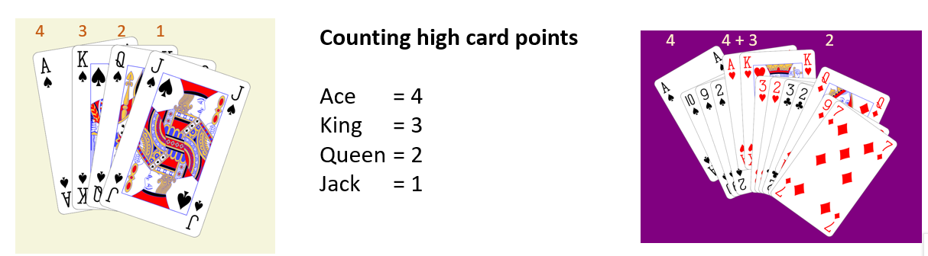

1. West does the same, as does North and East.
2. The pair with the largest total are then the ***Declarer***.
3. The player on Declarer’s left then selects a lead, here the Diamond 6.

1. Declarer’s partner then then places his cards, in order, face Up in front of him. This is called the Dummy. Declarer now decides the number of Tricks he will make, and in what denomination – a Suit, or No Trump. Declarer plays both hands – his own and Dummy.
2. Declarer selects a valid card from Dummy – you must follow suit – right hand opponent plays, and then Declarer. Now, each player turns over his card, pointing towards the winning Pair. The winner of the trick now leads.
3. Play continues in that vein until all 13 cards are played.

There is a style of scoring the Tricks that reward declaring, and making, a maximum number of Tricks – as opposed to simply settling for an ‘easy’ score.

But for now, we’ll let you just practice and enjoy playing the cards.

And try not to berate your partner… too much!